**SQL Project (2 May) (Sandra Yeo)**

**Code:**



**Databases**

**Region:**

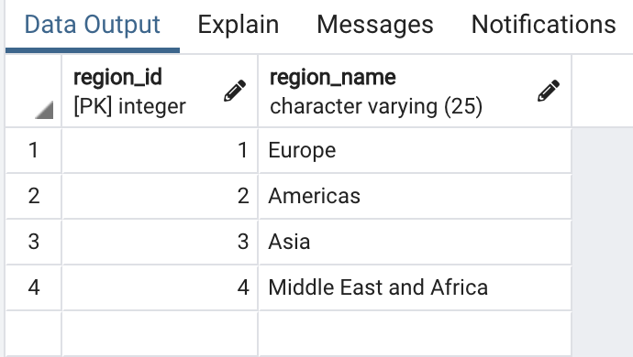

**Countries:**

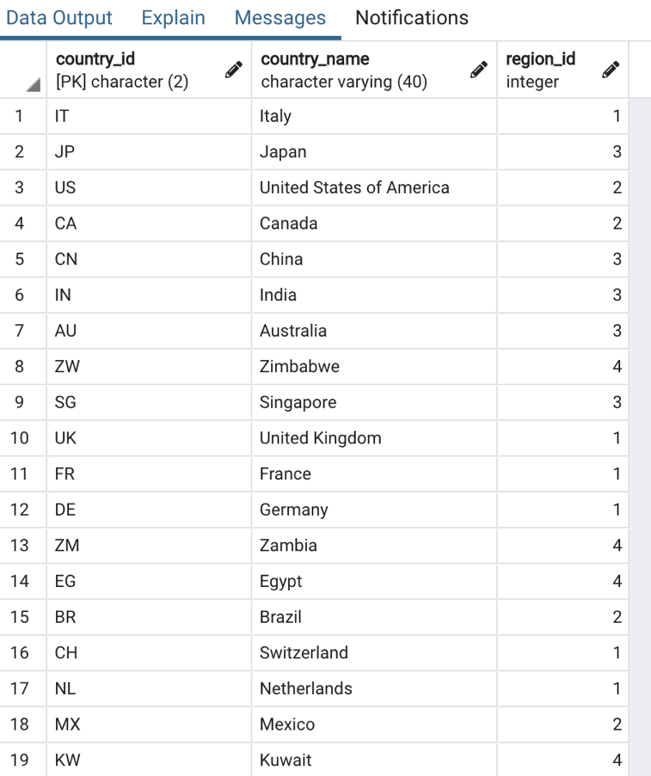

**Locations:**

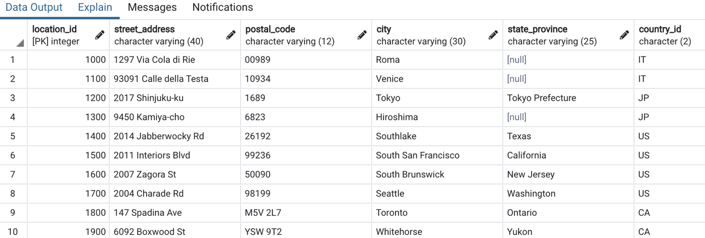

**Departments:**

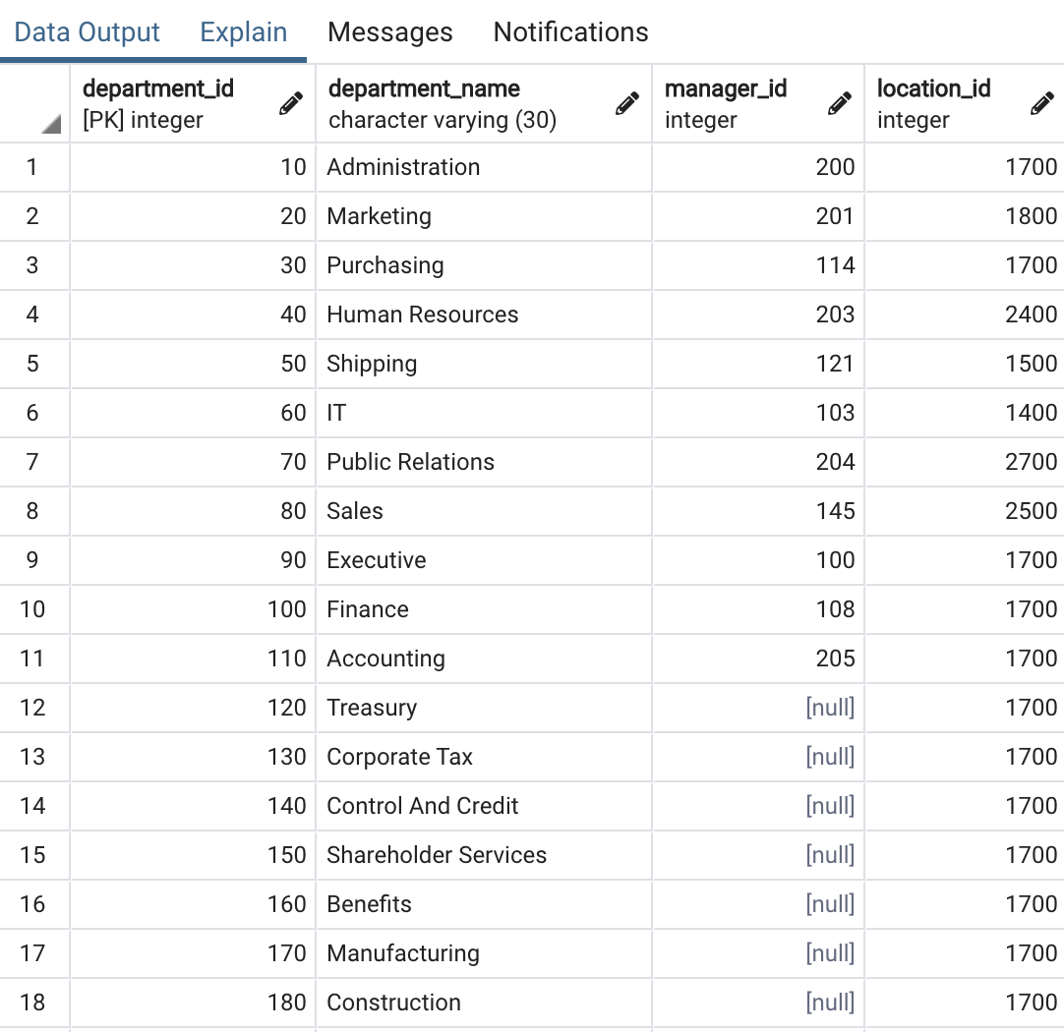

**Jobs:**

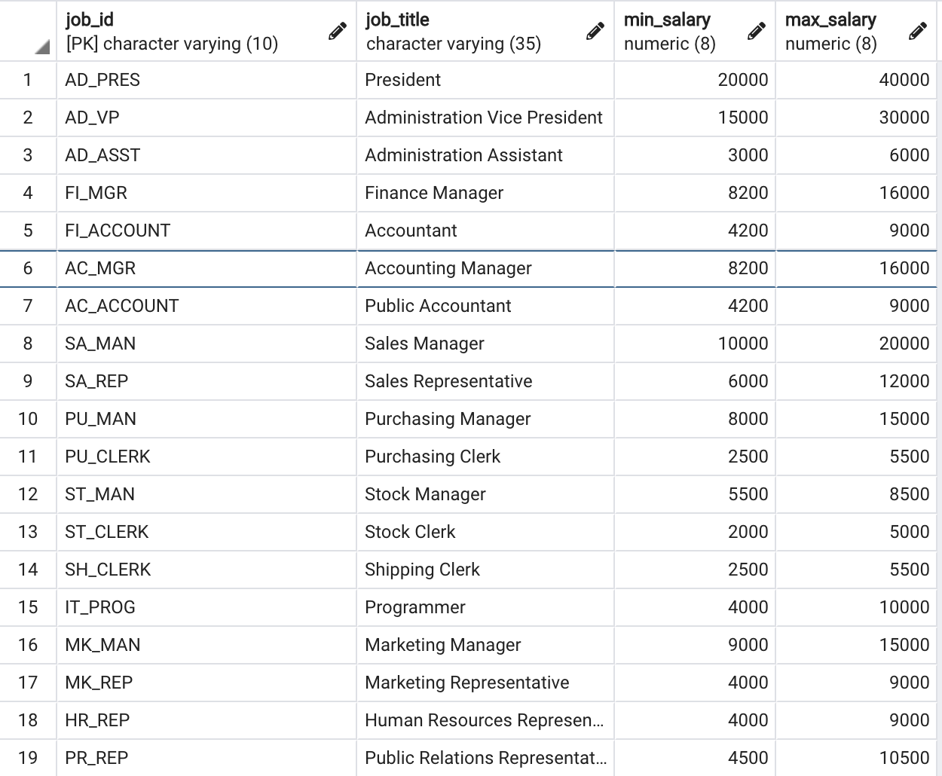

**Employees**

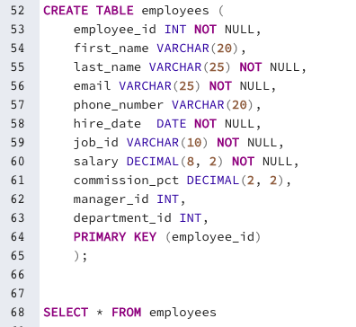

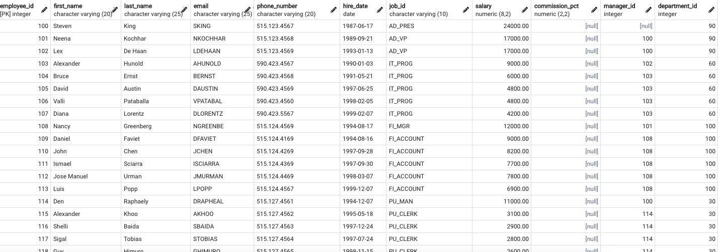

**Job_history:**

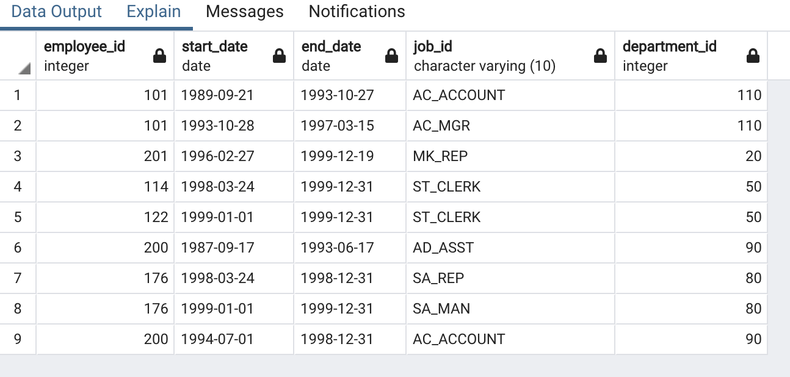

**Overall view (CREATE VIEW emp_details_view)**

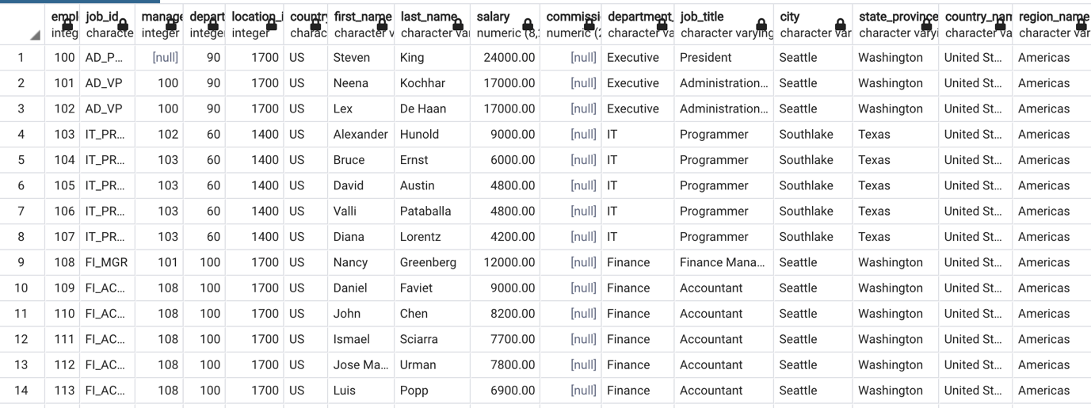

**Questions**

1. Write a query to display the names (first_name, last_name) using alias name “First Name", "Last Name"

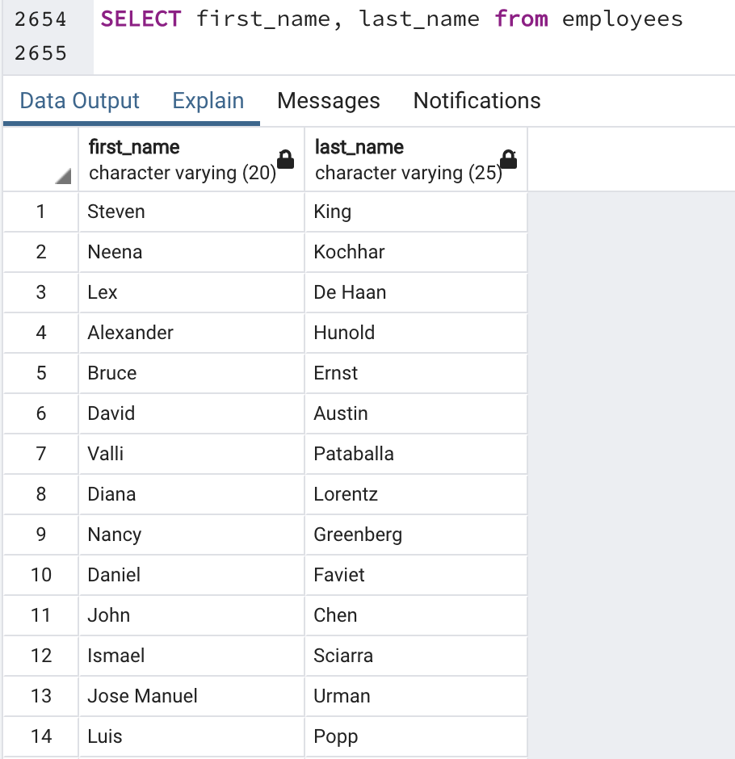

1. Write a query to get unique department ID from employee table **[12 results]**

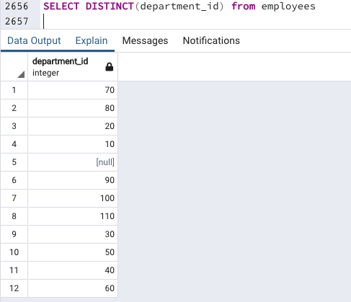

1. Write a query to get all employee details from the employee table order by first name, descending

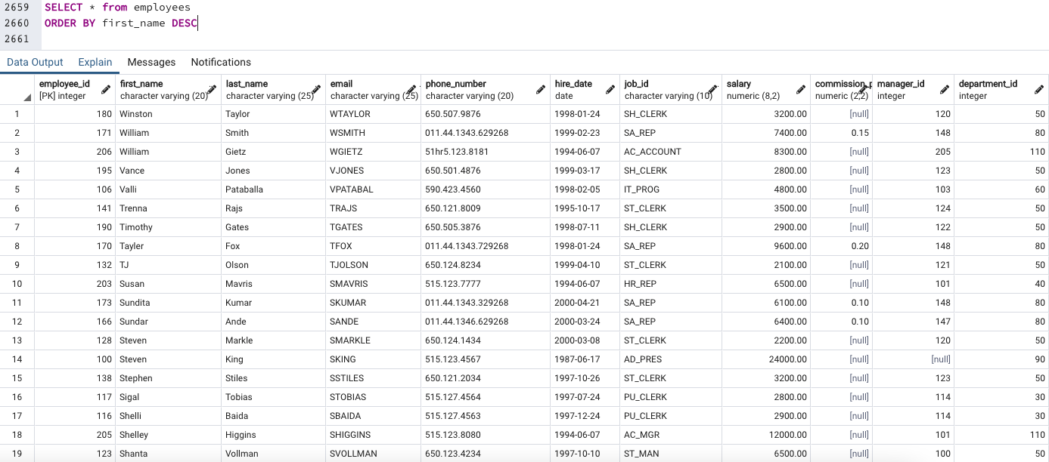

1. Write a query to get the names (first_name, last_name), salary, PF of all the employees (PF is calculated as 15% of salary) **[107 results]**

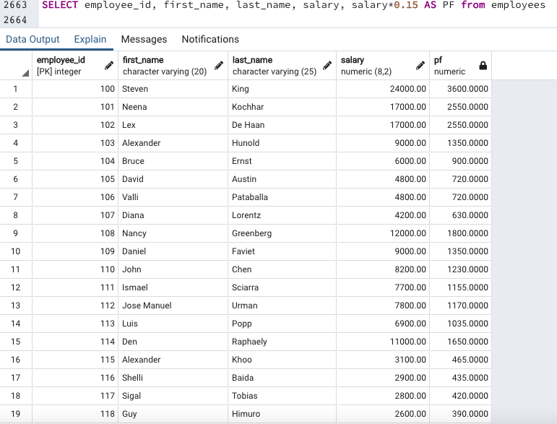

1. Write a query to get the employee ID, names (first_name, last_name), salary in ascending order of salary **[107 results]**

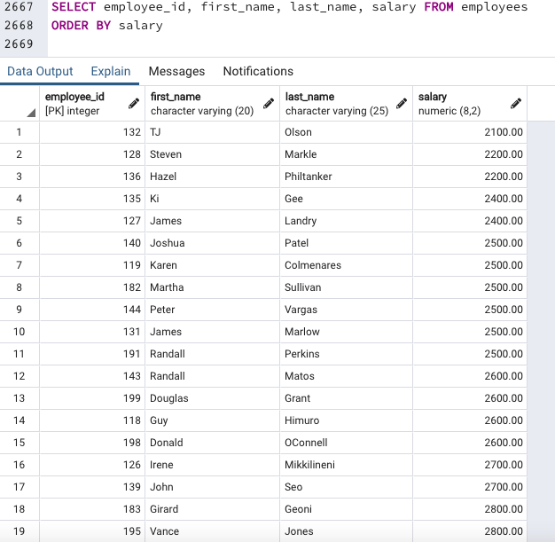

1. Write a query to get the total salaries payable to employees

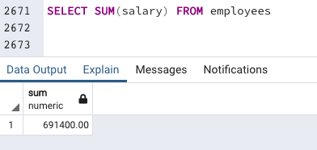

1. Write a query to get the maximum and minimum salary from employees table

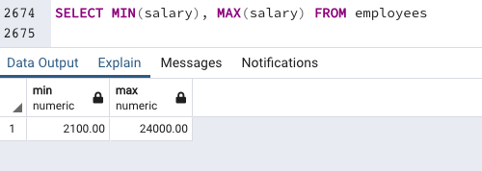

1. Write a query to get the average salary and number of employees in the employees table

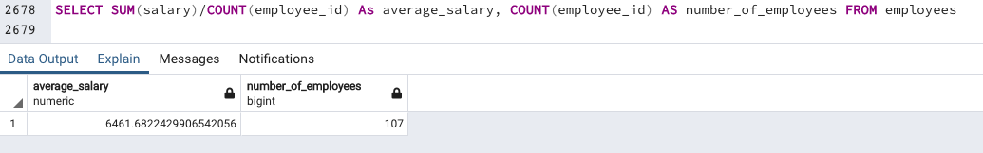

1. Write a query to get the number of employees working with the company

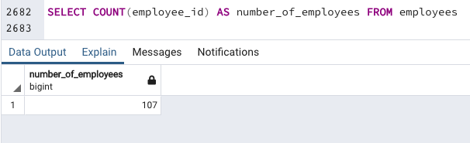

1. Write a query to get the number of jobs available in the employees table

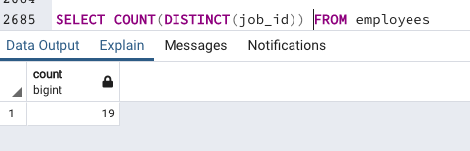

1. Write a query get all first name from employees table in upper case **[107 results]**

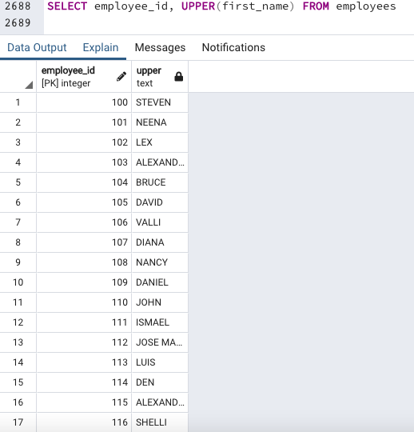

1. Write a query to get first name from employees table after removing white spaces from both side **[107 results]**

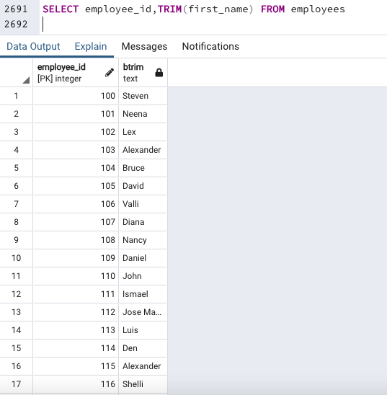

1. Write a query to get the length of the employee names (first_name, last_name) from employees table **[107 results]**

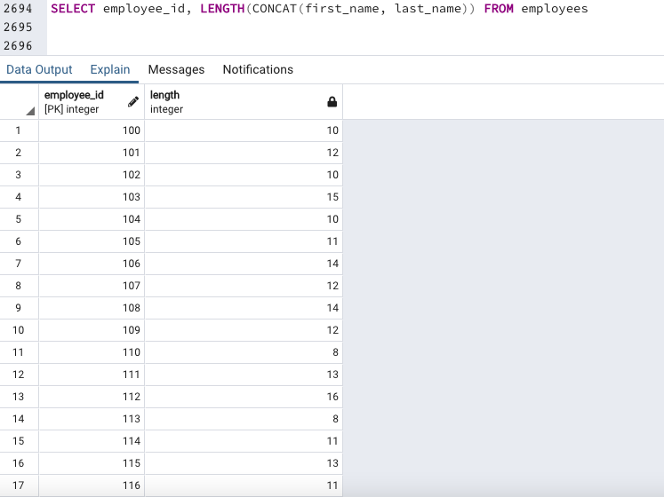

1. Write a query to display the name (first_name, last_name) and salary for all employees whose salary is not in the range $10,000 through $15,000. **[91 results]**

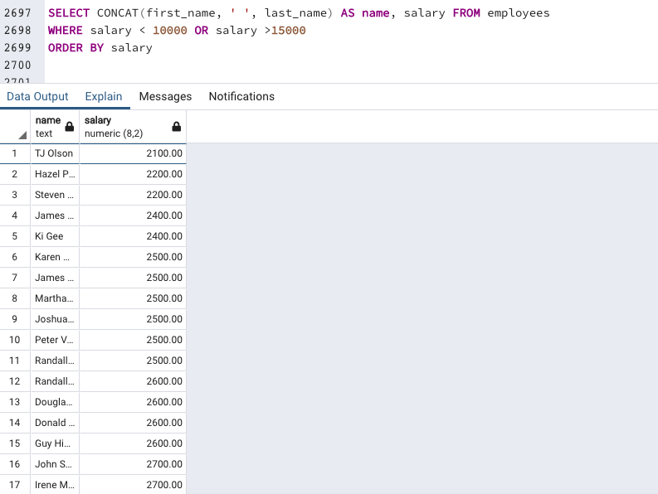

1. Write a query to display the name (first_name, last_name) and salary for all employees whose salary is not in the range $10,000 through $15,000 and are in department 30 or 100 **[10 results]**

